HADIQA
ASIF

CONTACT ME
+92 3141984051

hadiqaasif520@gmail. com

WORK EXPERIENCE

Professor
Superior group of colleges sohawa

2025 - 2026

Village Mohra Kalyal TEH Sohawa DIST
Jhelum, Pakistan

EDUCATION

Bachelor of computer science(3.75 CGPA)
I worked as a Computer Science Teacher at Superior Group of Colleges from March 2025 to January 2026. During this time, I taught both Intermediate and Bachelor's level classes. My responsibilities included preparing and delivering lectures, creating lesson plans, conducting quizzes and examinations, evaluating students' performance, and guiding them in academic projects. I was committed to creating a positive learning environment that encouraged students to develop their knowledge and problem-solving skills.

Gold Medalist

iqra university islamabad H-9
2022 - 2024

Professor
Aspire group of colleges sohawa

2026

BSC Double Mathematics(53.13 %)

Punjab University
2018- 2020

intermediate ICS(56.4 %)

Rawalpindi Board
Currently working as a Computer Science Lecturer at Aspire Group of Colleges, teaching Intermediate and Bachelor's level classes. Responsible for delivering lectures on core Computer Science subjects, preparing course materials, conducting assessments, and guiding students in both academic and practical learning.

2016 - 2018

Matriculation(65.9 %)

Android Application Developer
Iqra university

2022 - 2024

Rawalpindi Board
2014 - 2016

SKILLS
Graphic and Web Design
Developed a Flutter mobile application using Dart for semester and Final Year Projects. Collaborated with a team in an agile environment, ensuring smooth frontend-backend integration. Conducted testing and debugging to improve application performance and successfully presented the project.

Effective presenting and communication abilities.
Motivated to advance withinthe company and a quick learner.

Time management and setting priorities for the work.
Conceptualization and Copywriting

LANGUAGES

ENGLISH
IELTS B( 6 BANDS)

LANGUAGES

URDU

PUNJABI

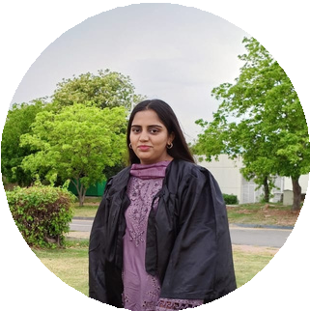
Microsoft Office (Excel, Word, PowerPoint).
HTML/CSS PYTHON JAVA

